Lesson 7 Demo 5
Docker Registry
Objective: Run a Docker Registry from official registry image

Tools required: Docker Configuration

Pre-requisites: Ubuntu Configuration, Docker

Steps to be followed:
- Pulling a Linux container
- Pushing the image to the local repository
- Running the new image

Step 1: Pulling a Linux container
1.1 Pull a recent version of the Centos Linux container.
sudo docker pull registry:2
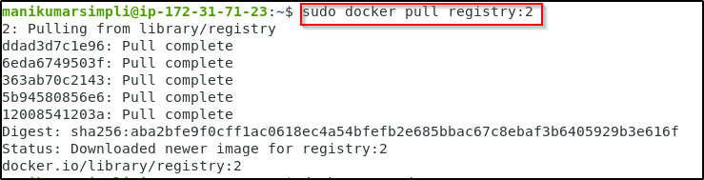
1.2 Run the registry in a new Docker container with port 5000 exposed
sudo docker run -d -p 5000:5000 \
--restart=always --name registry registry:2
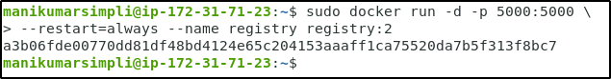

1.3 Pull another image from Docker Hub and store it in the local registry
sudo docker pull ubuntu
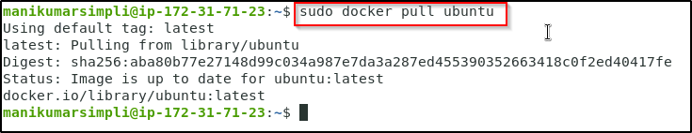
1.4 Tag the image for the local registry
sudo docker tag ubuntu localhost:5000/ubuntu

Step 2: Pushing the image to the local registry
2.1 Use the following command to push the image to a local registry:
sudo docker push localhost:5000/ubuntu
2.2 Remove the image from the local cache
sudo docker rmi ubuntu
2.3 Confirm that it has been removed
sudo docker images
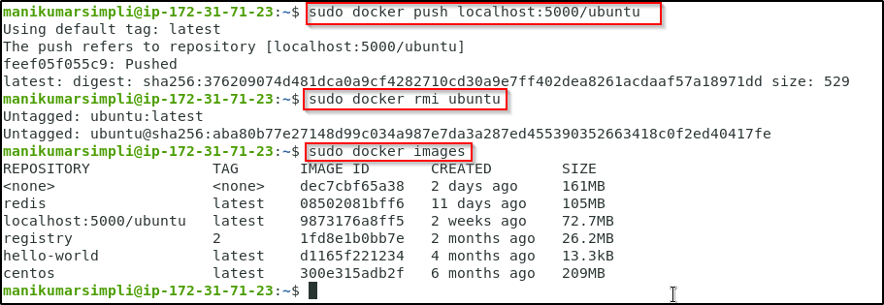

Step 3: Running the new image
3.1 Pull the image from the local registry
sudo docker pull localhost:5000/ubuntu
3.2 Confirm it is in the local cache
sudo docker images
3.3 Run the new image
sudo docker run -it --rm localhost:5000/ubuntu /bin/bash
3.4 Exit the container
exit
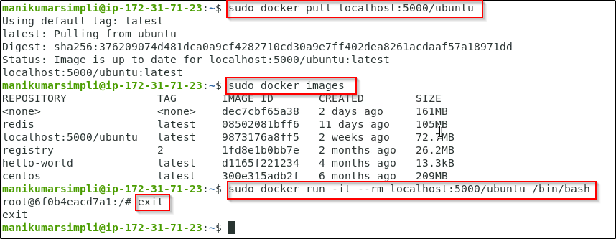
3.5 Clean up the images and containers
sudo docker rm -f $(docker ps -aq)
Note: In case you get a permission denied error as shown below, run the following
sudo chmod 666 /var/run/docker.sock
After running this, run the sudo docker rm -f $(docker ps -aq) command.
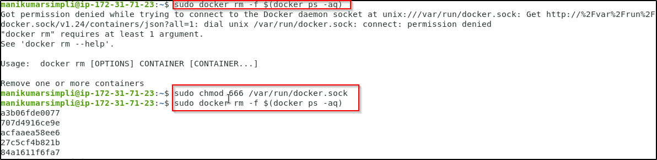
sudo docker rmi $(docker images -q)
